Short Answer Questions
- You have 12 minutes per question (36 minutes total) to answer the questions below.
- Once you have written your responses, you also need to type them.
- You will submit written and typed responses.

Use the painting shown below, The Third of May 1808 (1814) by Spanish artist Francisco Goya to answer all parts of the question that follows.

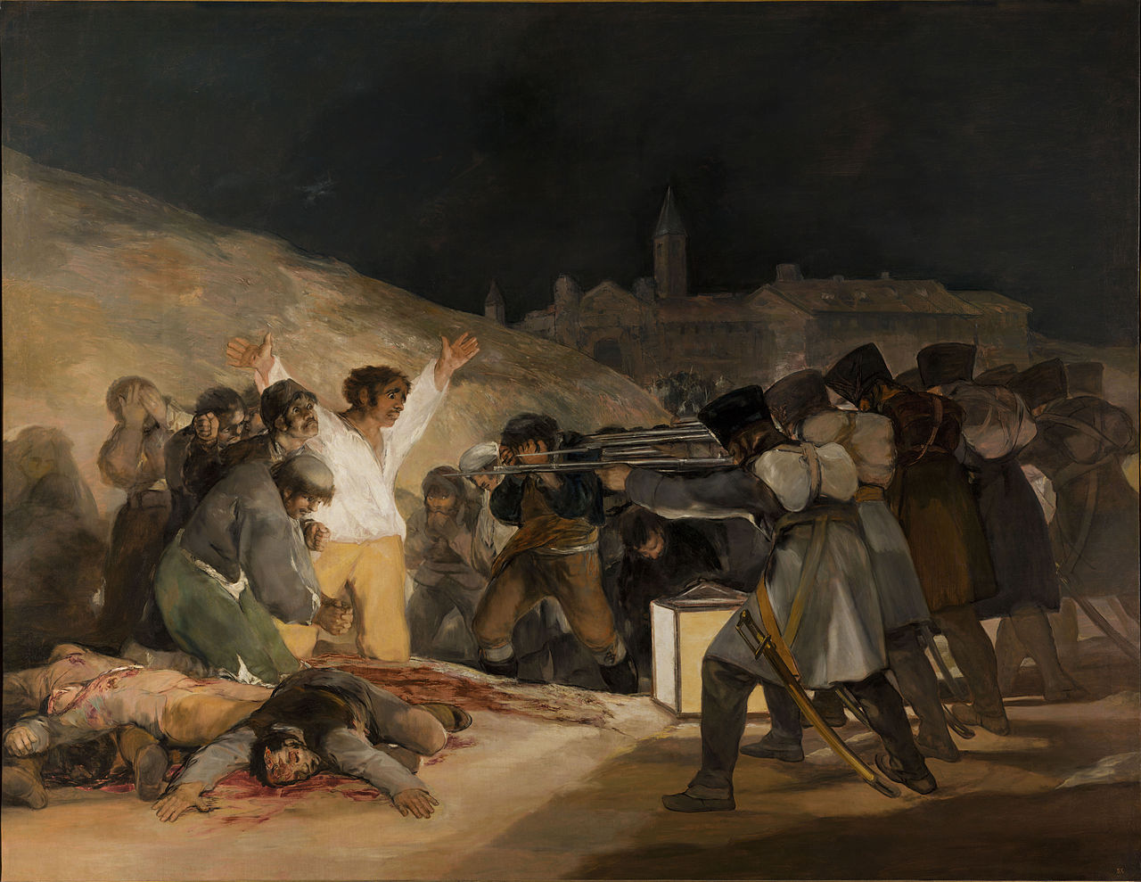
- Answer all parts of the question that follow:
- Identify and analyze TWO ways in which the painting reflects artistic trends in nineteenth-century Europe.
- Based on the painting and your knowledge of European history, identify and analyze ONE artistic trend in nineteenth-century Europe not shown in the painting

- Use the passage below to answer all parts of the question that follows.

“The effect of the news of the fall of Louis Philippe was electrifying. The passion of the hour was expressed in a flaming speech by [Louis] Kossuth [Hungarian revolutionary leader], who proved himself a consummate spokesman for a people in revolt….In a speech in the Diet, March 3, 1848, he voiced the feelings of the time, bitterly denouncing the whole system of Austrian government....Ten days later a riot broke out in Vienna itself…Metternich, who for thirty-nine years had stood at the head of the Austrian states…was now forced to resign.
…The effect produced by the announcement of Metternich’s fall was prodigious. It was the most astounding piece of news Europe had received since Waterloo. His fall was correctly heralded as the fall of a system hitherto impregnable. ”
--Charles Downer Hazen, Professor of History at Columbia University, Modern European History, 1917

- Identify and analyze TWO pieces of evidence that supports Hazen’s contention regarding the fall of Metternich.
- Identify and analyze ONE piece of evidence that refutes Hazen’s contention regarding the fall of Metternich.

- Use the passage below and your knowledge of European history to answer all parts of the question that follows.

“Darkest England, like Darkest Africa, reeks with malaria. The foul and fetid breath of our slums is almost as poisonous as that of the African swamp. Fever is almost as chronic there as on the Equator. Every year thousands of children are killed off by what is called defects of our sanitary system. They are in reality starved and poisoned, and all that can be said is that, in many cases, it is better for them that they were taken away from the trouble to come.
….much of the misery of those who lot we are considering arises from their own habits. Drunkenness and all manner of uncleanness, moral and physical, abound.
….The grimmest social problems of our time should be sternly faced, not with a view to the generation of profitless emotion, but with a view to its solution.”
--William Booth, social reformer and founder of the Salvation Army, In Darkest England and the Way Out, 1890

- Identify and explain ONE cause for the conditions described by Booth in the passage.
- Identify and explain TWO ways in which the conditions described by Booth had improved by the end of the century.

