America’s missing slave memorials: It’s time to truly acknowledge our bloody past

Add to list
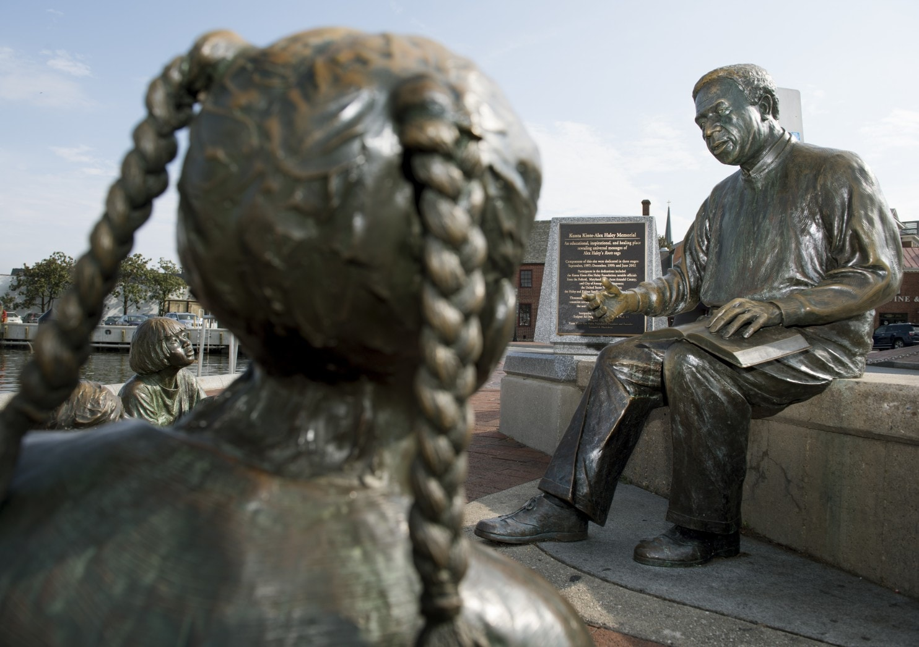
A view of the Kunta Kinte-Alex Haley Memorial at City Dock in Annapolis last year. (Linda Davidson/The Washington Post)
By Petula Dvorak
Columnist for the Washington Post
August 28, 2017
This has happened before.
A monument erected in a prominent place was removed in the darkness of night. The Ku Klux Klan was invoked.
But this memorial, installed more than 30 years ago in the most touristed part of Annapolis, was dedicated to an African slave.
It took only two days for racist vandals to remove a bronze plaque in honor of Kunta Kinte, ancestor of “Roots” author Alex Haley, back in 1981.
Left in its place was a business card that read in big red letters: “You have been patronized by the KKK.” Above that, in black, it said, “The Invisible Empire, Knights of the Ku Klux Klan.”
Of course, it was the KKK, neo-Nazis and other white supremacists who descended on Charlottesville this month to protest the removal of a statue of Robert E. Lee. Their demonstration ended in clashes with counterprotesters that left 32-year-old Heather Heyer dead and many others injured.
Right now, there are about 1,700 Confederate monuments scattered across the country — every one of them a reminder of what’s at stake as we debate our history and how to mark it. In some cities, including Baltimore and Annapolis, statues honoring the heroes of the South were removed this month in the dead of night.
Is a statue there to honor? Glorify? Teach? Remember? The idea of heritage and history is an important part of this discussion.
And if that’s the case, the 1,700 monuments don’t come anywhere near to telling the full story of our history or honoring our heritage.
Where, exactly, are all the statues to the millions of enslaved men and women who were so crucial to the foundation of our great nation?
Where are the monuments to Nat Turner, Madison Washington, Gabriel Prosser or “Jemmy” — all men who led slave rebellions on behalf of their people. Aren’t their heroic actions — and the bloody results — as worthy of memorializing as the Confederacy?
Yet there’s no statue for Virginian Nat Turner, who on Aug. 22, 1831, led 70 men to kill his master, his wife and their children with axes and then dozens of other whites. In his home state, all he gets is a roadside marker on the site of the insurrection.
Compare that with the massive statues along Monument Avenue in Richmond, the former capital of the Confederacy, where Gen. Robert E. Lee commands a 60-foot-high view of the city. What should happen to him and Confederate rebels Jefferson Davis, Stonewall Jackson, Matthew Fontaine Maury and J.E.B. Stuart? Should the city remove them or continue adding more statues that recognize the contributions of African Americans, as it has already started to do? Maybe Nat Turner should get a statue on Monument Avenue.

It took 18 years of debate and planning for Charleston, S.C., to erect a statue of Denmark Vesey, a freed slave who was a founder of Emanuel AME Church and was executed for organizing a foiled slave revolt in Charleston in 1822.
Just a few months ago, three years after it was unveiled, city officials believe damage they found on the Vesey statue may have been the result of vandals trying to topple it.
This is what happens when America tries to remind itself of its bloody past.
Back in Annapolis, neither the culprit nor the missing Kunta Kinte memorial was ever found. But the people of Annapolis rallied to raise enough money to replace the plaque and add a sculpture of author Alex Haley reading to a trio of multiethnic children.
It’s now a beloved Annapolis fixture. Kids sit in Haley’s lap and pose alongside the bronze children. And on an August morning, it did exactly what every memorial, monument and statue should do.
“You must hear me now, with more than your ears!” Harvey Kramer read to three of this grandchildren. He was reading a quote from Haley’s book, and he explained to the three little imps swirling around him that this is “a part of American history.”
Kramer, 79, graduated from the Naval Academy and was showing his family his old stomping grounds in Annapolis. He said most of his classmates were white, like him. And there was little conversation at the time about diversity in history.
The memorial to Haley and Kunta Kinte gave him that chance to talk to his children about a painful piece of U.S. history.
Another family with children frolicking around the statue said the memorial sparked conversation about the time they watched the seminal TV miniseries “Roots” as kids and when, exactly, they should begin talking with their young children about slavery.
“We need honesty about this,” said the father, who was visiting Annapolis from Minneapolis.
Confederate statues and monuments don’t really bother Jacqueline Jones, who is from Brooklyn, nor do they have an impact on her daughter, Christen Jones, who lives in Maryland.
“That’s history. It happened, and we shouldn’t try to erase it,” said Jacqueline, who is 57 and African American.
It’s the absence of other memorials that bothers her.
“How about some more Harriet Tubman or Frederick Douglass monuments?” she asked.
Sure, those exist. But not many. Statues to African Americans on American soil include ones to Duke Ellington, Jackie Robinson and Martin Luther King Jr., but we have done little to remember the millions of Americans who lived as slaves and built the economic powerhouse that the United States quickly became.
Our African American memorials are uplifting, friendly, even sanitized.
Throughout the world, there are starker and more powerful monuments to the human terror that was the slave trade and the astounding resilience of those who survived it.
Barbados has a powerful sculpture of a man showing his broken chains. It is known as Bussa, the name of the leader of that island’s 1816 slave revolt. The statue went up in 1985.
Tanzania has a haunting sculpture unveiled in 1998 that shows forms with chains around their necks, slightly lowered into the ground, the way slaves were kept at the nearby slave market.
Back in 1976, Veracruz, Mexico, celebrated Gaspar Yanga with a statue of the leader of a 1570 slave revolt who became the leader of his colony.
America can do better.
On the promenade along the Savannah River in Savannah, Ga., there is a granite-and-bronze African American monument showing a black family with broken chains at their feet.
When it was proposed in 2001, there was a citywide furor over the quote by poet Maya Angelou on its base: “We lay back to belly in the holds of the slave ships in each others’ excrement and urine together, sometimes died together, and our lifeless bodies thrown overboard together.”
It was too harsh, some city leaders said.
“Maya Angelou’s description was a little far out,” said David Jones, a black City Council member. “I myself wouldn’t want to be reminded of that every time I look at it. History . . . can hurt.”
Yes, the truth hurts.
The quote stayed. And certainly it started many, many conversations.

