Hello, You!
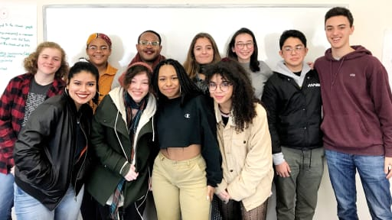

Name__________________________________________ Period____

Do you need to sit near the front of the room? Yes No
What is your favorite song? Please list the artist/band________________________________________
Question | Answer
Why are you taking AP European History?

How would past teachers describe you?

What was the most amazing thing about your summer?

Whom do you admire and why?

If you could meet any historical figure, who would it be? What would you ask that person?

When you have spare time, how do you use it?

You like it when teachers…

Where is the most interesting place you have been?

What job do you think you would be really good at?

Where do you see yourself in five years?

What have you heard about this class and Ms. Bass?

What else would you like Ms. Bass to know about you?

This is going to be a wonderful journey…

Brace yourself!

